Data 205 Project Plan: RideOn Bus Stops

Data
Bus Stops (dataMontgomery): Active bus stops directly from MC DOT's OneStop database. Includes stops maintained by both Montgomery County and municipalities, and with bus service from both Ride On and WMATA buses. The data has 5,253 rows and 15 columns. Mainly interested in ‘Total Benches,’ ‘Total Shelters,’ ‘Total Trashcans,’ and ‘Total Signs’ variables.
Montgomery County Ride On Stops: All RideOn bus stops in Montgomery County. This data has 5 columns and 4,828 rows. Includes key variables ‘Stop Code’ and ‘Town.’
Census.gov: Total population of cities and Census Designated Places within Montgomery County.
I plan to join the first two datasets which I’ll use for the majority of my analysis. A potential issue is the fact that the Bus Stops dataset originally includes MetroBus stops in addition to RideOn bus stops. Unlike RideOn buses, Metro buses have a fare to ride which could be a significant factor in determining the amount of infrastructure those stops have. Taking this into account, I plan to separate the routes that include MetroBus stops from those that are solely RideOn bus stops to investigate if this factor truly has an impact.

Research goals and questions:
- Identify factors that influence bus stop infrastructure throughout Montgomery County
  - How does the population of cities within Montgomery County relate to their bus stop infrastructure?
    - Method: Group by city and calculate the proportion of bus stops with benches, shelters, trashcans, and signs given the total number of bus stops. Graph scatterplot of calculated proportion vs. city population that’s colored by city.
  - Is there a statistically significant difference in the amount of bus stops with benches/shelters/trashcans/signs between cities in Montgomery County?
    - Method: Run Anova test for each category (benches, shelters, ect.) with the null hypothesis being there is no difference in the proportion of bus stops with infrastructure across cities.
  - Is there a statistically significant difference in infrastructure between RideOn and Metro Bus stops?
    - Method: Separate bus stops that include RideOn and Metro routes. Run hypothesis tests for each category (benches, shelters, ect.) with the null hypothesis being that there is no difference in the proportion of bus stops with infrastructure between RideOn and RideOn with Metro bus stops.
  - Is a stop more likely to have a bench if it has a shelter?
    - Methods: Heatmap including total benches and total shelters variables and/or check correlation between total benches and total shelters
  - Do bus stops that have more routes going through them have more infrastructure?
    - Method: Create new variable ‘Total Routes.’ Create scatterplots with ‘Total Routes’ and infrastructure variables (benches, shelters, ect.)
  - What is the average distance between stops with a bench within each city?
    - Method: Group by city and use Nearest Neighbors to calculate average distance between stops with benches. Nearest Neighbors implementation will use linear units and be based on the street network of Montgomery County.
- Identify areas that significantly lack bus stop infrastructure
  - Which city has the largest average distance between bus stops with a bench?
    - Method: Refer to results of question 1.f.
  - Which city has the smallest proportion of bus stops with infrastructure?
    - Method: Group by city and calculate the proportion of bus stops with benches, shelters, and trashcans given the total number of bus stops. Visualize with a filled stacked barplot.
- Suggest specific bus stops where infrastructure requires improvement in Montgomery County
  - Which bus stops will have the greatest impact if they’re improved (i.e. adding a bench or shelter)?
    - Determining the answer to this question will take into account the answers to questions 2.a and 2.b, the results of the Nearest Neighbors model, the number of routes the stop services, the population of the area, feasibility regarding location and space…
Tools and resources
Python will be my analysis tool within which I’ll utilize a variety of packages.
Data ingestion and cleaning: Numpy and pandas for cleaning N/As, creating new variables, and getting basic statistics.
Exploratory data analysis: Seaborn and matplotlib for basic visualizations.
Main analysis: For my Nearest Neighbors model I plan to use geopandas, NearestNeighbors, osmnx, and networkx. For my hypothesis and anova testing I’ll also utilize scipy, statsmodels, and pandas.
Visualizations: For maps I plan to use geopandas and matplotlib as well as plotly or folium for interactivity. Given that I make a dashboard, I plan to use tableau.

Risks and mitigations:
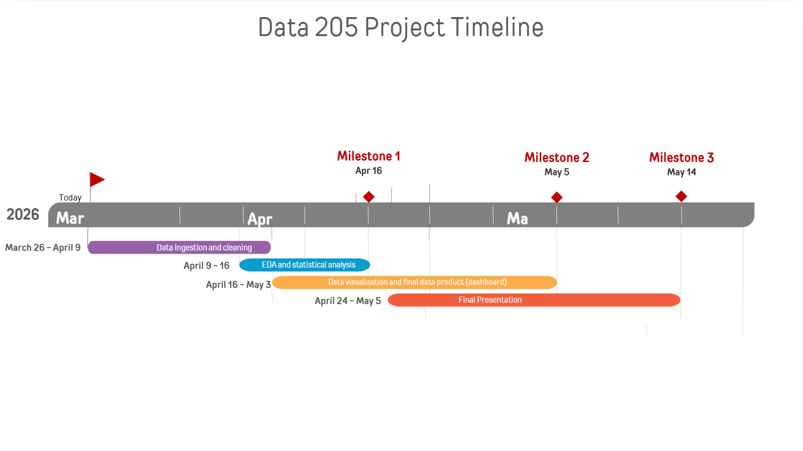
While joining my datasets a potential risk is that they won’t align as seamlessly as I’d hope. While I plan to join using the ‘Stop Code’ column, I may consider using the latitude and longitude variables to join instead in the case ‘Stop Code’ doesn’t work. I may even look for additional data that includes town and stop ID instead. Another problem is that the census dataset is not easily joinable with my other two datasets because it doesn’t have ‘Stop Code’ or ‘Stop ID’ columns. While I was planning to just consider it separately, I could try and find a dataset that includes zip code and stop code or ID to join to the census data.

Milestones:

